10/22/23

Griffin Rzonca

AD9850 Notes

* Take 8-bit word input telling it what freq. To generate
* Can generate either a square or a sine wave
* Square wave comes out of “QOUT” pin, uses a comparator
* Sine wave comes out of “IOUT” pin
* [How to Use Arduino DDS Frequency Signal Generator AD9850 : 7 Steps - Instructables](https://www.instructables.com/How-to-Use-Arduino-DDS-Frequency-Signal-Generator-/)
  + Guide uses an Arduino, but still useful for wiring and pin assignments

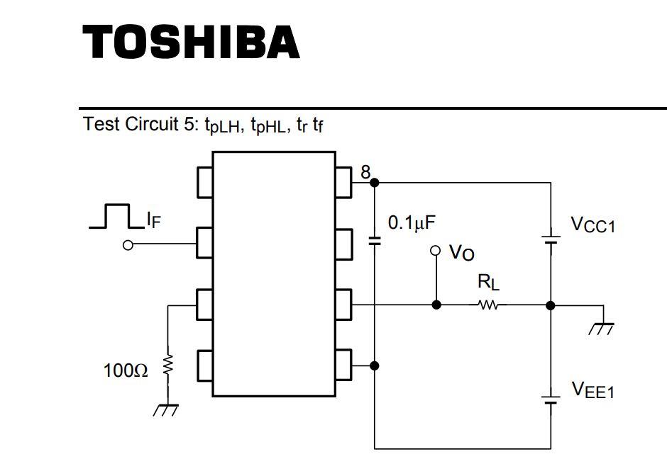

* From the AD9850 datasheet, why does Vo have a tie to Vcc1 and Vee1?
* What is Vee?

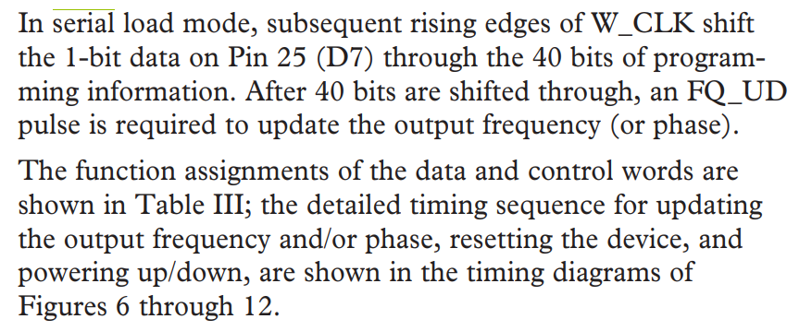

* ^How to use the serial load feature instead of using 8 GPIO pins